DIS-AFR-Mali-Dogon bronze Figure

Rarity finest old Dogon bronze Figure - Container Mali

7 inch fine old patina

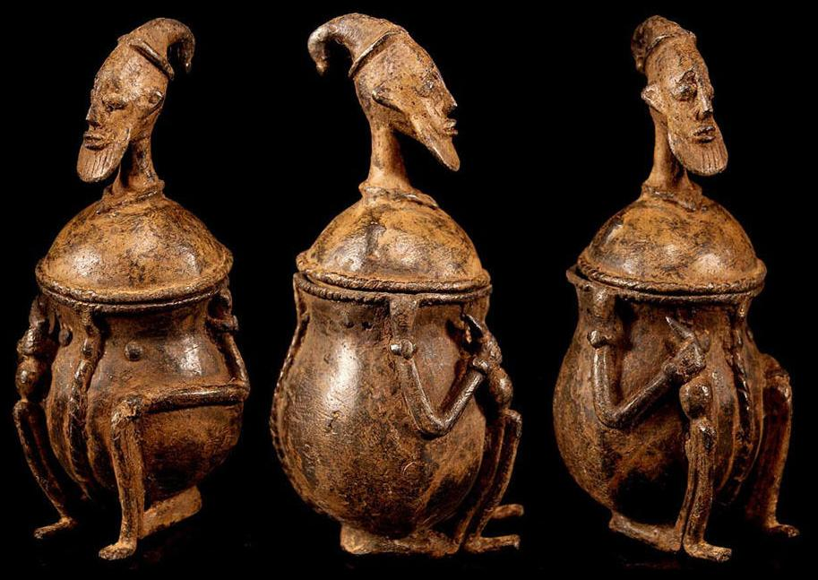

# Order details

Printer friendly page

## Sales order

Sold by [collector-girl77...](http://myworld.ebay.com/collector-girl777) ( [472](http://feedback.ebay.com/ws/eBayISAPI.dll?ViewFeedback&userid=collector-girl777) )

+ Show additional actions

### Delivery package 1 of 1

Estimated delivery Monday, Jun 6, 2016 -Monday, Jun 13, 2016

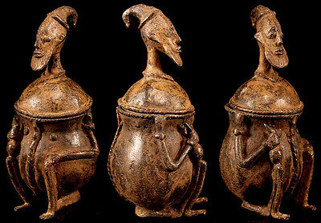

#### [Rarity finest old Dogon bronze Figure - Container Mali](http://www.ebay.com/itm/262450537063)

|  |  |
| --- | --- |
| **Item price** | $175.00 |
| **Quantity** | 1 |
| **Item number** | 262450537063 |
| **Shipping service** | Standard Shipping |

[Contact seller](http://contact.ebay.com/ws/eBayISAPI.dll?FindAnswers&frm=3998&iid=262450537063&redirect=0&requested=collector-girl777)

[Return item](https://www.ebay.com/rtn/Return/ReturnViewSelectedItem?transactionId=1825165152016&itemId=262450537063&_trksid=p2057872.m2749.l3185)

## Shipping address

Ralph J Coffman Jr  
149 Atlantic Ave

Swampscott MA 01907-2427

United States

## Order total

|  |  |
| --- | --- |
| **Subtotal** | $175.00 |
| **Shipping** | $28.00 |

**Total**

$203.00

[View PayPal transaction](http://payments.ebay.com/ws/eBayISAPI.dll?UnifiedCheckoutSummaryRedirect2PP&itemid=262450537063&transId=1825165152016&buyerorseller=0)

Order placed on

Wednesday, May 25, 2016

Payment method

PayPal

Payment date

Wednesday, May 25, 2016